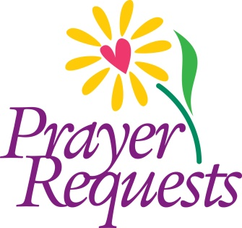**For Our Reformation Church Family**

**For Healing:** Phyllis, Karin, Margery, Margie, Tom, Wharton Jesse, Jody, George, Mildred, Joanne, Linda, Elva, Benny, Eric

**For Our Homebound:** Betty, Evelyn, Lieschen, Clara

**Others for Whom We Pray**

**For Healing:** Alicia, Linda, Gayle, John, Irene, Gregory, Bob, Michelle

**For all those affected by the COVID-19 pandemic.**

**For those serving in the military.**

**For those who have no one to name them.**